SQL HR Data Exploration Project

Questions :

1. Which job titles have the highest salaries?
2. What is the maximum salary in each office?
3. What is the total salary expenditure for each office?
4. Which job title has the highest average salary across all offices?
5. How many employees have a salary above the company-wide average salary?
6. Which office has the highest number of employees?
7. Rank each job titles based on their salaries
8. Rank Top Earners in Each office based on their job title
9. Which employees have the highest salaries in the company and who are the employees with the next highest salaries after them?
10. Which job titles have the highest salaries?

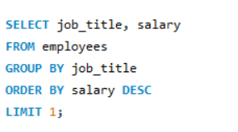

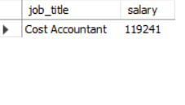

1. What is the maximum salary in each office?

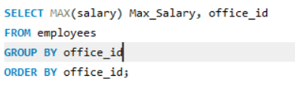

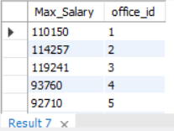

1. What is the total salary expenditure for each office?

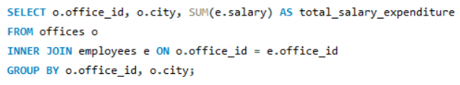

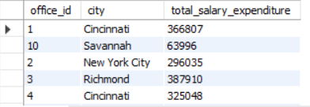

1. Which job title has the highest average salary across all offices?

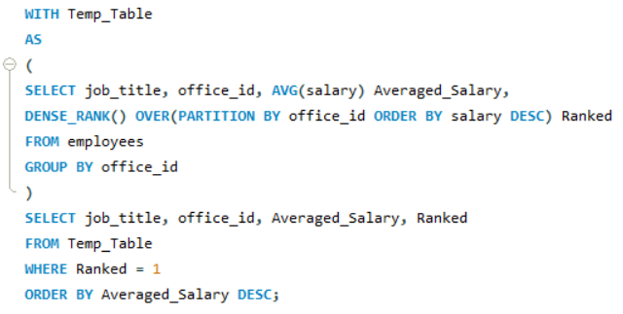

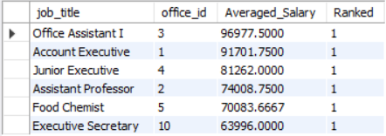

1. How many employees have a salary above the company-wide average salary?

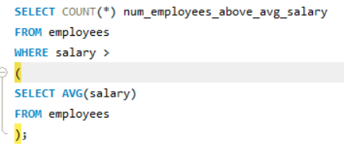

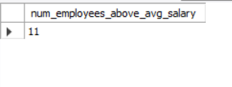

1. Which office has the highest number of employees?

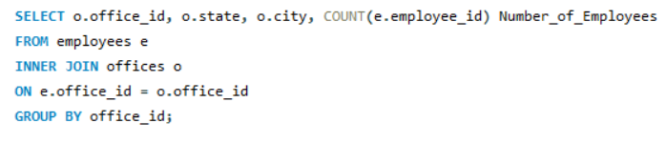

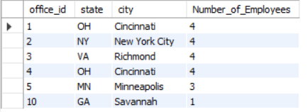

1. Rank each job titles based on their salaries

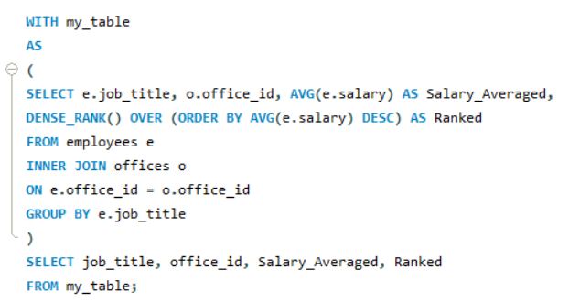

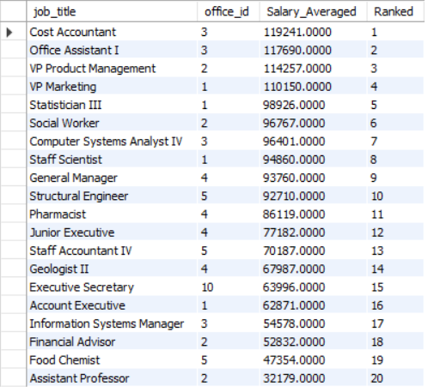

1. Rank Top Earners in Each office based on their job title

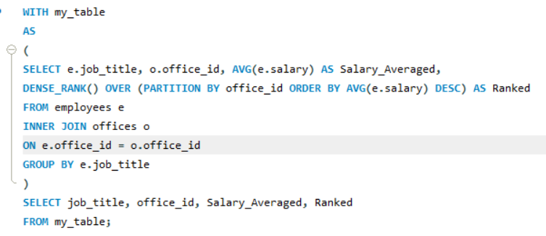

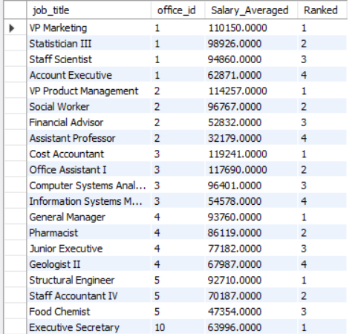

1. Which employees have the highest salaries in the company and who are the employees with the next highest salaries after them?

